assignment 1

phani varshitha

2023-09-24

## Scatterplot between sales and price

#install.packages("ISLR")  
library(ISLR)  
data<- Carseats  
head(Carseats)

## Sales CompPrice Income Advertising Population Price ShelveLoc Age Education  
## 1 9.50 138 73 11 276 120 Bad 42 17  
## 2 11.22 111 48 16 260 83 Good 65 10  
## 3 10.06 113 35 10 269 80 Medium 59 12  
## 4 7.40 117 100 4 466 97 Medium 55 14  
## 5 4.15 141 64 3 340 128 Bad 38 13  
## 6 10.81 124 113 13 501 72 Bad 78 16  
## Urban US  
## 1 Yes Yes  
## 2 Yes Yes  
## 3 Yes Yes  
## 4 Yes Yes  
## 5 Yes No  
## 6 No Yes

plot(Carseats$Sales, Carseats$Price, main = "Scatterplot between Price and Sales", xlab = "Sales", ylab = "Price",abline(Carseats$Sales,Carseats$Price))

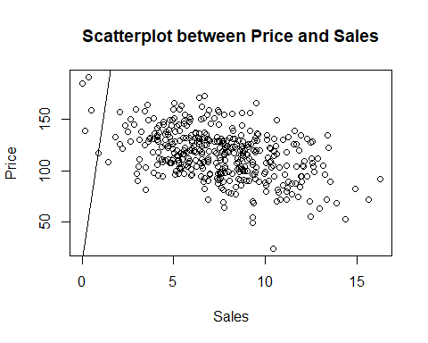

barplot(Carseats$Price)

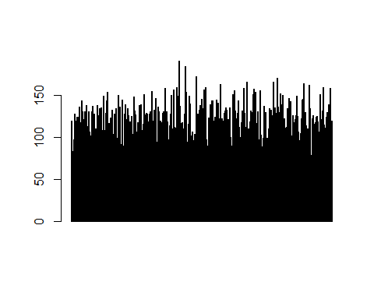

#maximum value attribute of advertisement

max(Carseats$Advertising)

## [1] 29

#summary of carseats

summary(data)

## Sales CompPrice Income Advertising   
## Min. : 0.000 Min. : 77 Min. : 21.00 Min. : 0.000   
## 1st Qu.: 5.390 1st Qu.:115 1st Qu.: 42.75 1st Qu.: 0.000   
## Median : 7.490 Median :125 Median : 69.00 Median : 5.000   
## Mean : 7.496 Mean :125 Mean : 68.66 Mean : 6.635   
## 3rd Qu.: 9.320 3rd Qu.:135 3rd Qu.: 91.00 3rd Qu.:12.000   
## Max. :16.270 Max. :175 Max. :120.00 Max. :29.000   
## Population Price ShelveLoc Age Education   
## Min. : 10.0 Min. : 24.0 Bad : 96 Min. :25.00 Min. :10.0   
## 1st Qu.:139.0 1st Qu.:100.0 Good : 85 1st Qu.:39.75 1st Qu.:12.0   
## Median :272.0 Median :117.0 Medium:219 Median :54.50 Median :14.0   
## Mean :264.8 Mean :115.8 Mean :53.32 Mean :13.9   
## 3rd Qu.:398.5 3rd Qu.:131.0 3rd Qu.:66.00 3rd Qu.:16.0   
## Max. :509.0 Max. :191.0 Max. :80.00 Max. :18.0   
## Urban US   
## No :118 No :142   
## Yes:282 Yes:258   
##   
##   
##   
##

#Interquartile range of price

IQR(Carseats$Price)

## [1] 31